How to install the Lancaster New City Cavite Software:

Step 1: Copy and Paste the “Lancaster Installer” Folder from the CD to your own computer.



Step 2: Open the folder.

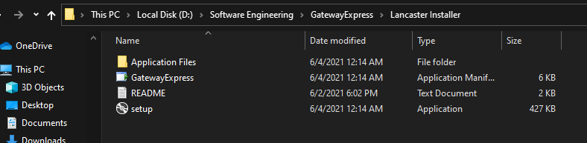

Step 3: Click and Install the setup.exe or GatewayExpress.application the same way as you would normally install an application.

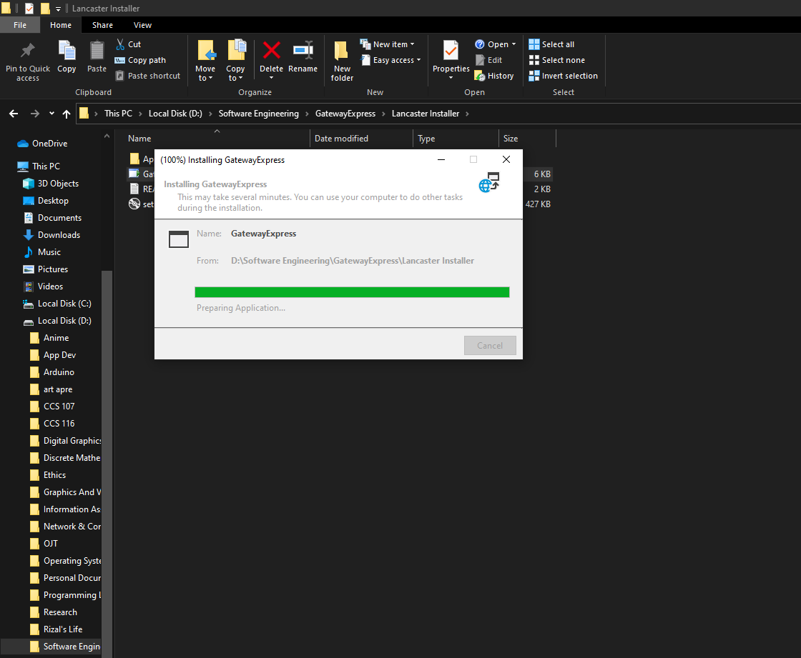

Step 5: Wait Until it is completed then you are good to go.

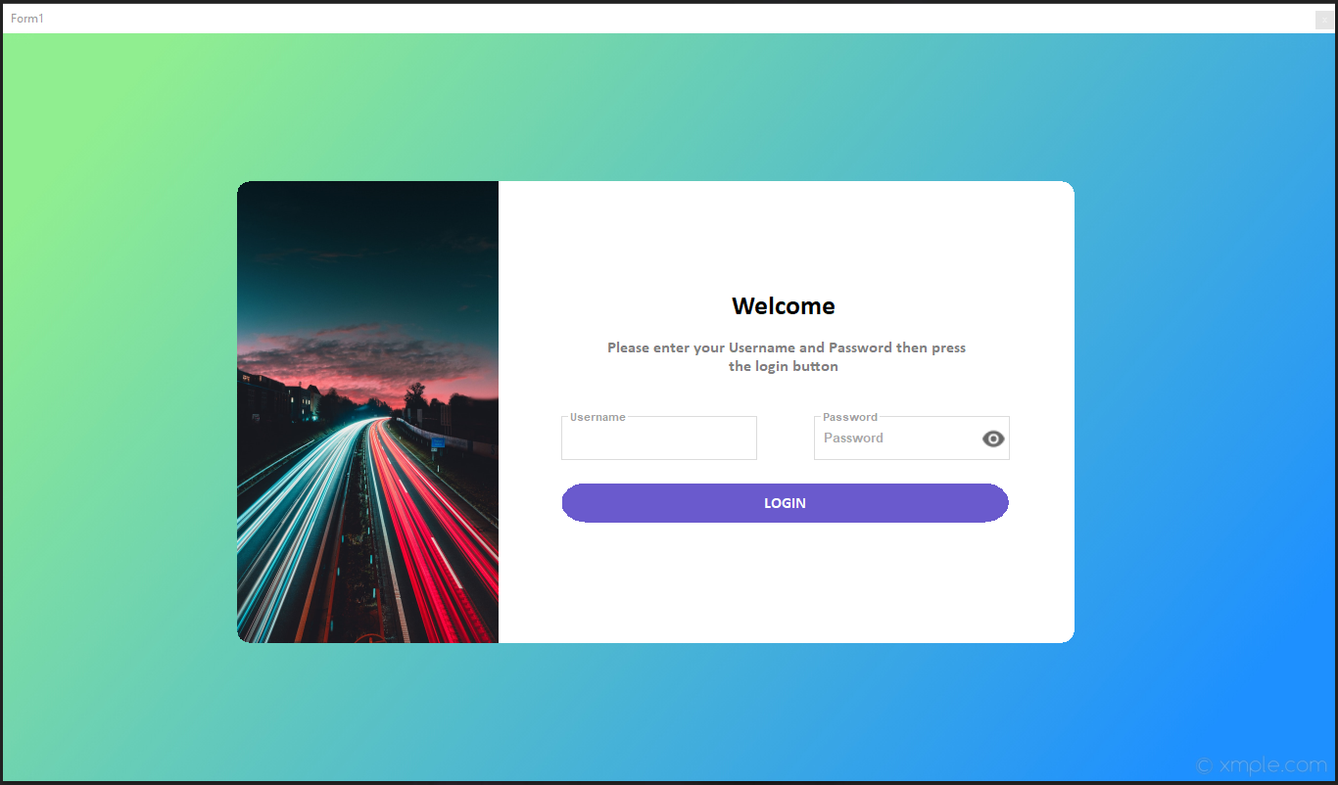

How to uninstall the Lancaster New City Cavite Software:

Step 1: In the search box on the taskbar, type Control Panel and select it from the results.

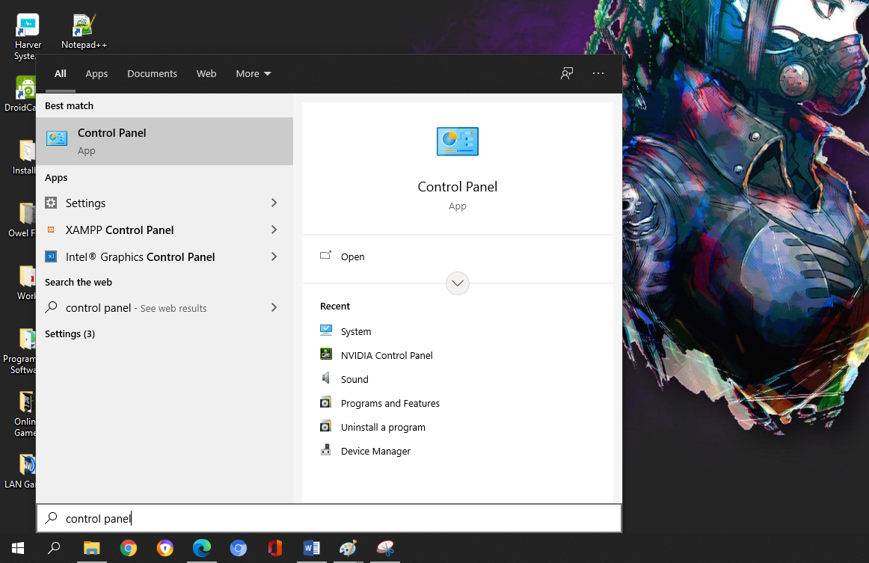

Step 2: Select Programs > Programs and Features.

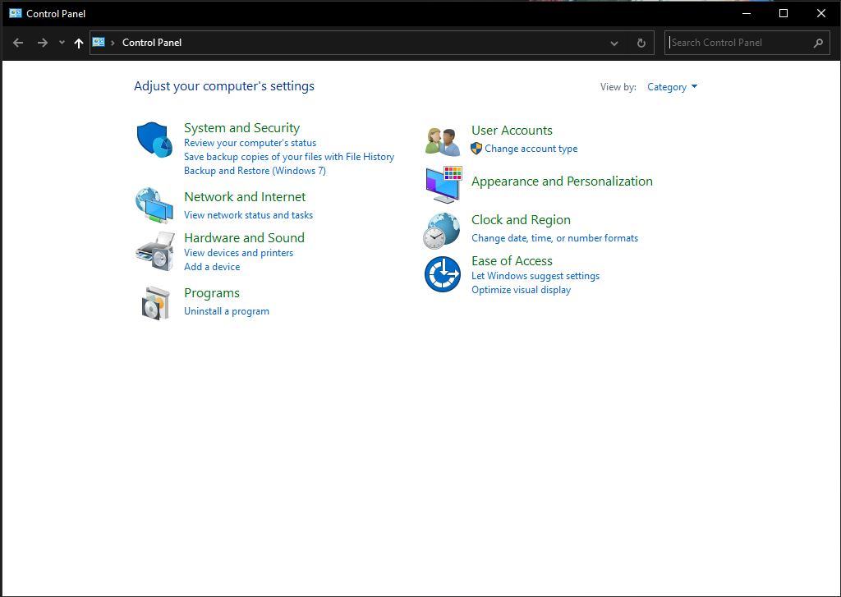

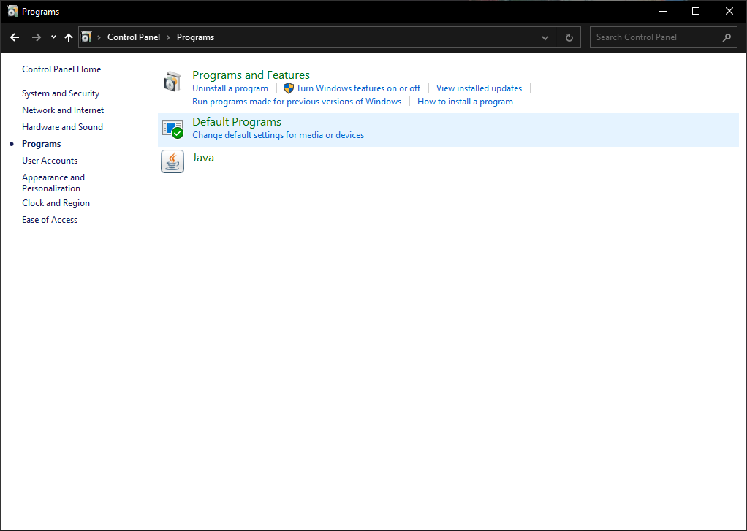

Step 3: Press and hold (or right-click) on the program you want to remove and select Uninstall or Uninstall/Change. Then follow the directions on the screen.

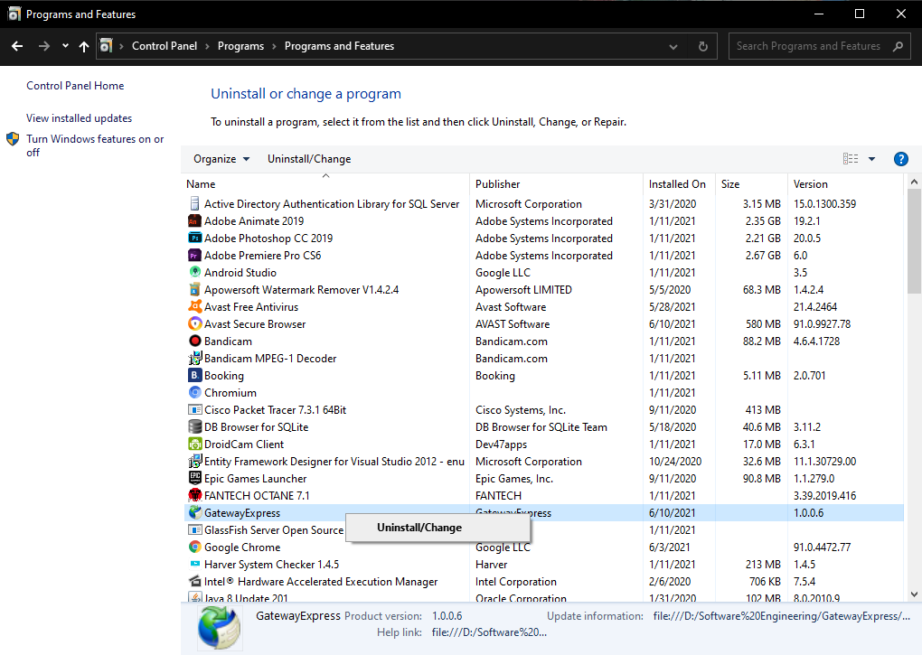

How to use the Lancaster New City Cavite Software:

Step 1: Open the app and it will bring you to the Login Form.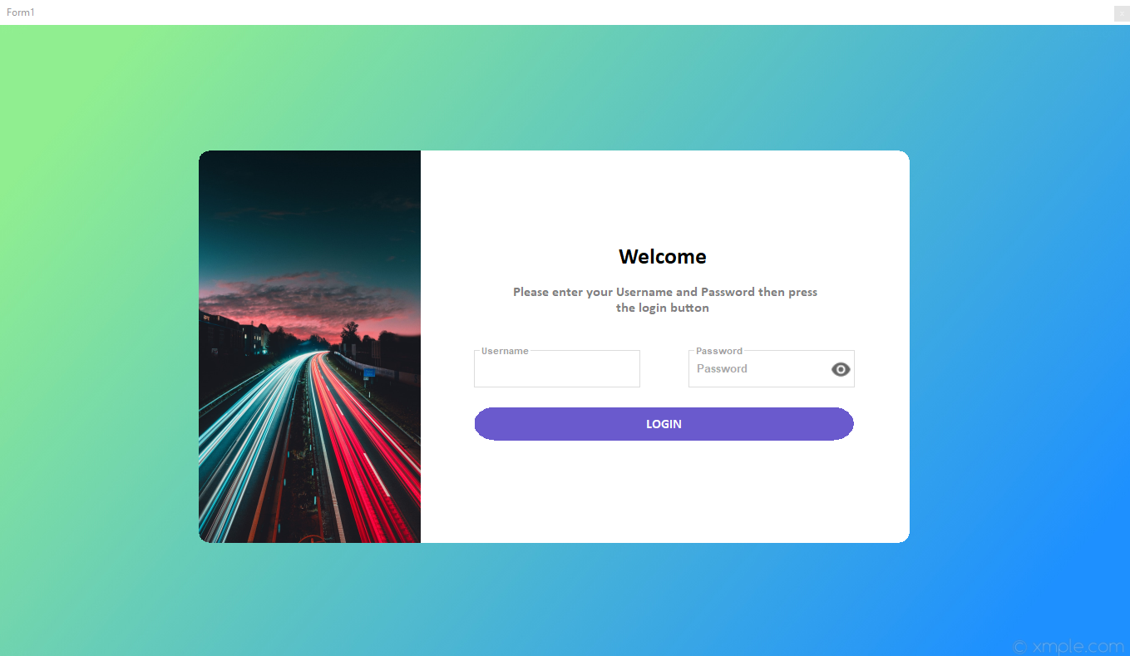

Step 2: Login using the admin account registered on the database. Example Account:

Username: admin

Password: asd

Once you are login using the admin account it will load the splash screen to load the database for the system.

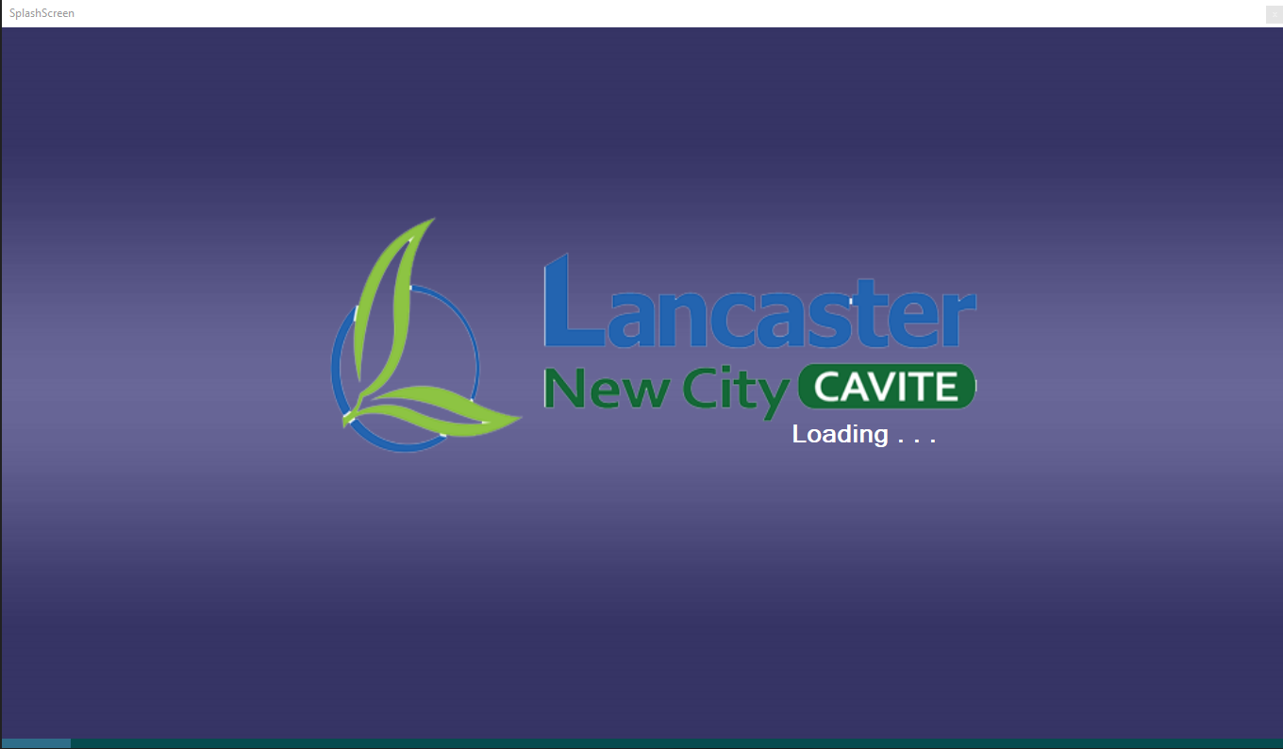

Step 3: Wait until the loading screen is done and once it’s done it will load the Dashboard.

**PAGE MENU / SIDEBAR NAVIGATION**

**TRANSACTIONS COUNT FOR TODAY**

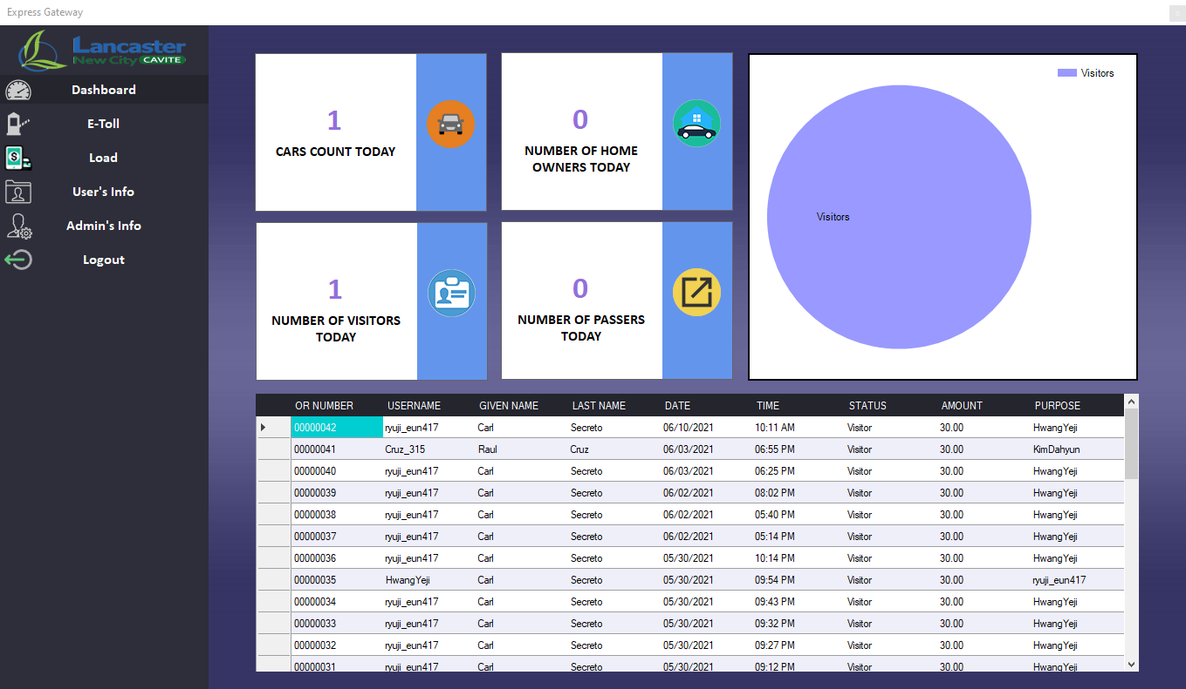

**TRANSACTION HISTORY**

Step 4: The dashboard will display the history of all the transactions done on the tollgate as well as the current count for the users who passed on the gate for that day. It will also divide the count for each user type, the Home Owners, Visitors, and Passers.

**TRANSACTION INFO**

Step 5: For the transaction click the E-Toll on the sidebar navigation.

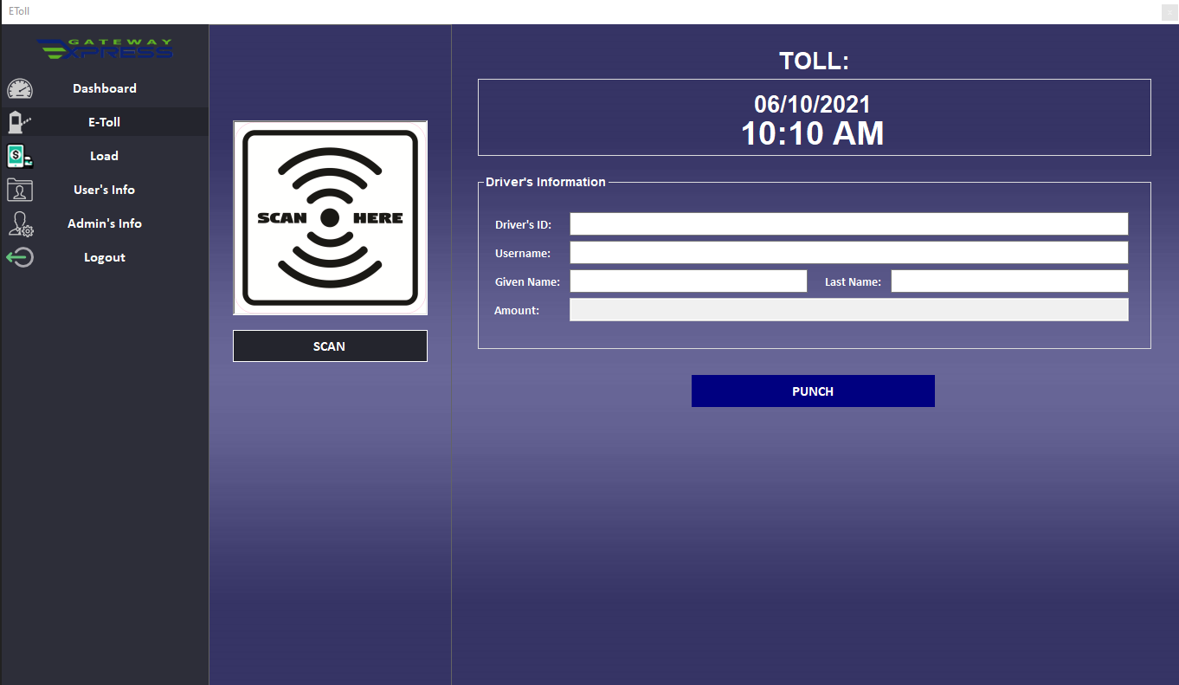

**BUTTON FOR MANUAL TRANSACTION**

**THIS WILL DISPLAY WHAT YOU SCANNED**

**BUTTON TO SCAN THE QR CODE**

Step 6: Once you are on the E-Toll Form point the QR code on your webcam then click the scan button. The scan button will display the picture of the QR code you scanned on the picture box that says SCAN HERE. If it successfully scanned the QR code, it will display the Driver’s ID or User’s ID in the 1st text and it will automatically fill up all the following details. It will also display the amount that will be a charge to the user if the homeowner it is ₱0.00 if visitor ₱30.00, and if passer ₱50.00. It will automatically charge on the user’s account.

Step 6.1(Optional): For users that don’t have the QR code on them, you can manually put the driver’s ID or User’s ID on the 1st textbox and it will automatically fill up everything and all you need to do is click the “PUNCH” button to charge them.

Step 6.2(Optional): For drivers or users who don’t have an account ask for a cash transaction for ₱50.00 and if the user pays for it, just click the "PUNCH" button and it will insert the data as a manual punch.

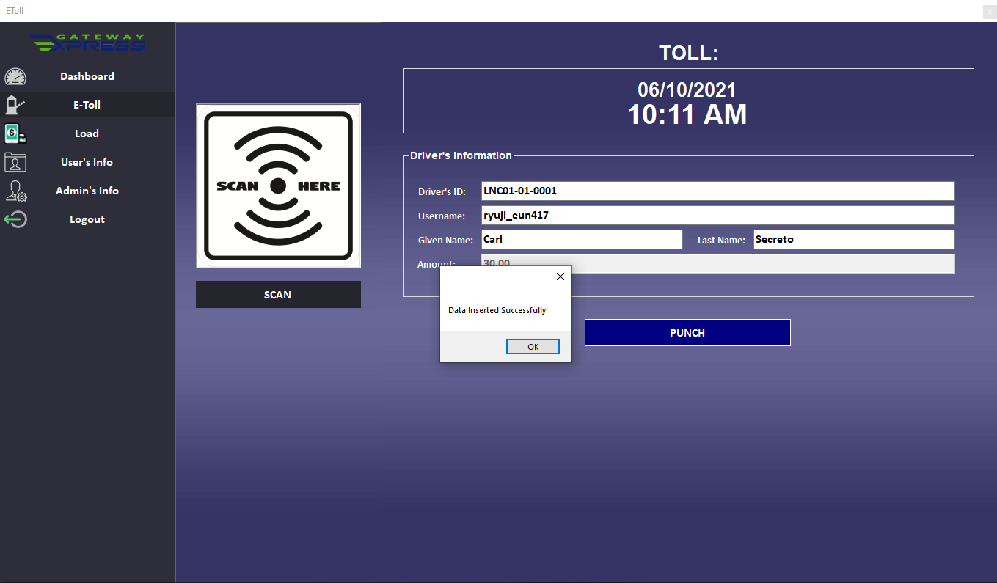

**TRASACTION ALERT**

Step 7: If the transaction is successful, it will pop up a message that says “Data Inserted Successfully!” and just click OK to close it and clear all the info so you can do the next transaction.

Step 7.1 (Optional): If the user is a visitor once you click the OK on the pop-up message, it will pop up the printable visitor’s pass that will show you on what number are you on the visitor count for today then click the “PRINT” button.

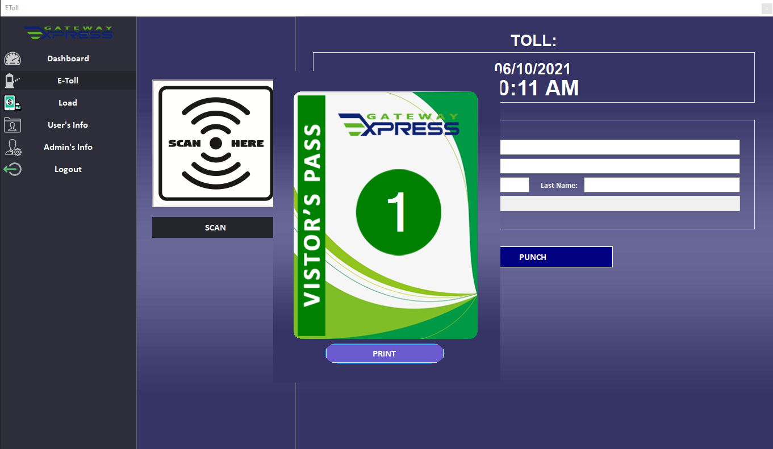

**PRINTING BUTTON**

Step 7.2 (Optional): Once you click the print button it will show you the print preview, then proceeds to print the Visitor’s Pass.

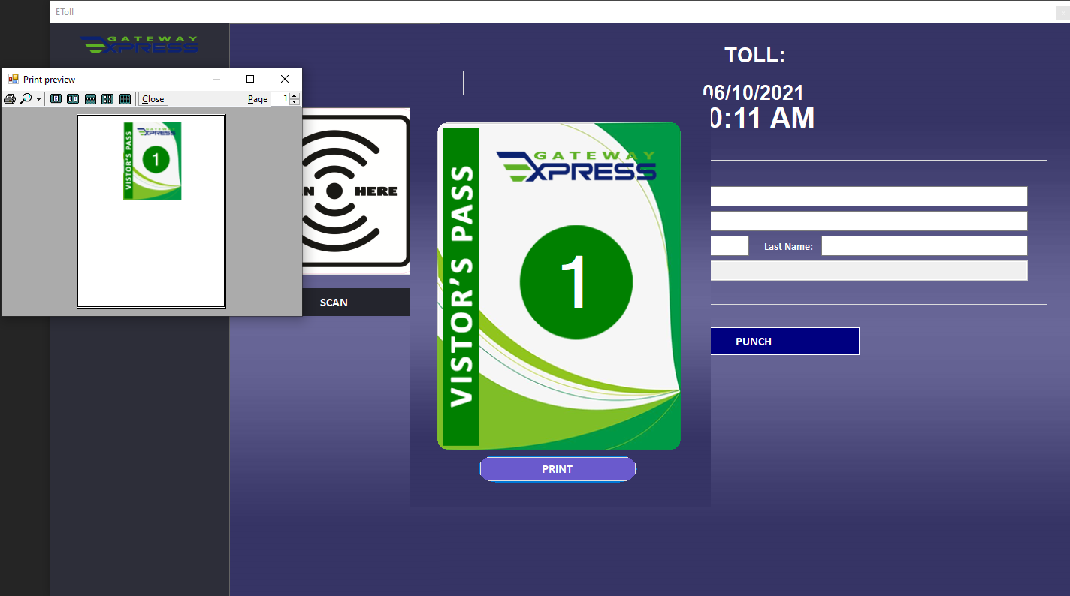

**BUTTON FOR MANUAL TRANSACTION**

**THIS WILL DISPLAY WHAT YOU SCANNED**

**BUTTON TO SCAN THE QR CODE**

**PRINT PREVIEW**

Step 8: Go to the Load Menu Page by clicking the “Load” button on the sidebar navigation.

**TRANSACTION INFO**

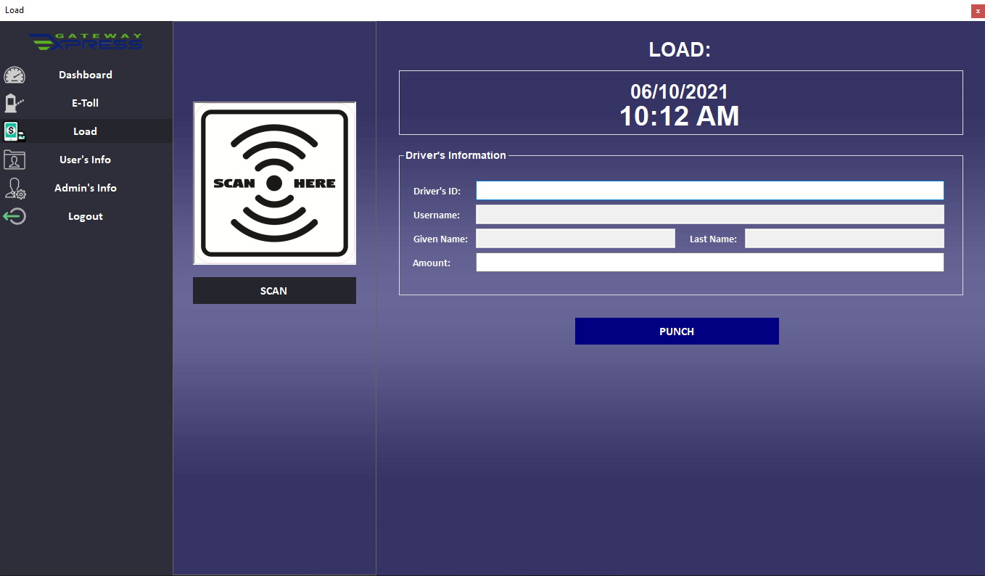

Step 9: Once you are on the Load Form similar to E-Toll all you need to do is to do point the QR code on your webcam then click the scan button. The scan button will display the picture of the QR code you scanned on the picture box that says SCAN HERE. If it successfully scanned the QR code, it will display the Driver’s ID or User’s ID in the 1st text and it will automatically fill up all the following details.

Step 9.1 (Optional): For users that don’t have the QR code on them, you can manually put the driver’s ID or User’s ID on the 1st textbox and it will automatically fill up all the following details.

Step 10: Put the amount you want to load on the last textbox.

Step 11: Ask for the payment via cash, then click the PUNCH button and it will add the amount to your account’s balance.

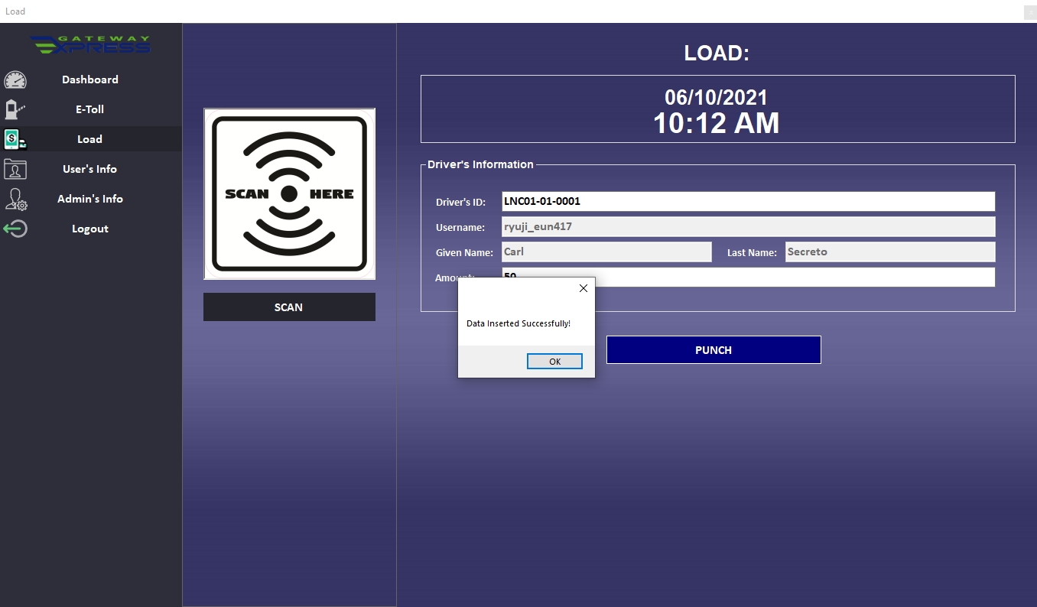

**TRASACTION ALERT**

Step 12: If the transaction is successful, it will pop up a message that says “Data Inserted Successfully!” and just click OK to close it and clear all the info so you can do the next transaction.

Step 13: Go to the User’s Info Menu Page by clicking the “User’s Info” button on the sidebar navigation.

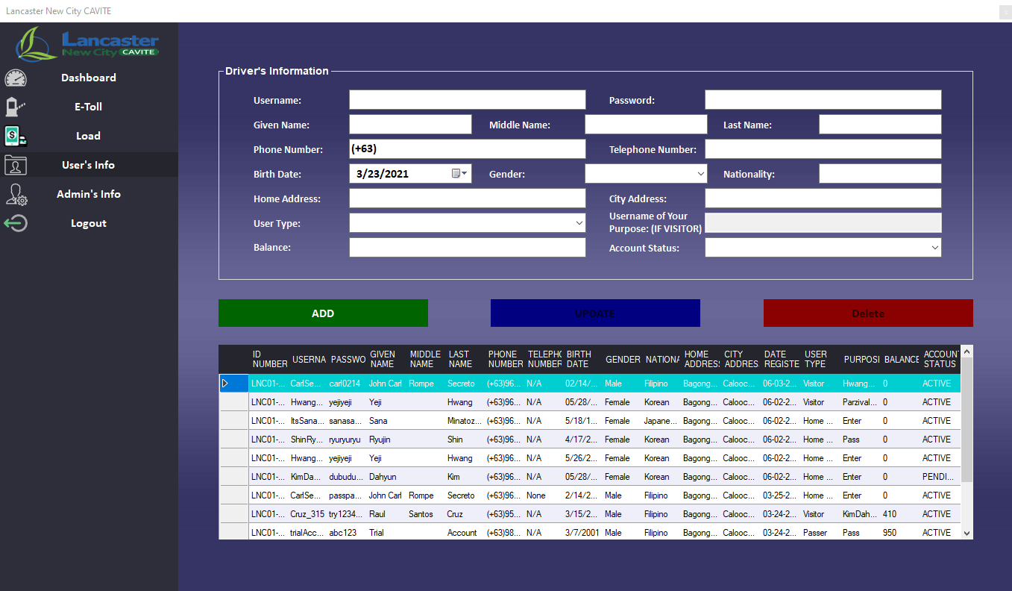

**USER’S INFO**

**PROCESS BUTTON**

**USER’S INFO TABLE**

Step 13. Once you are on the User’s Info Form the form will display all the User’s info below.

Step 14: To add a new user, please fill up all the necessary details.

Step 15: Once you are done, click the “ADD” button and if the user doesn’t have a similar phone number or username on the previews users it will give the account a new user ID and the new user will be inserted into the database.

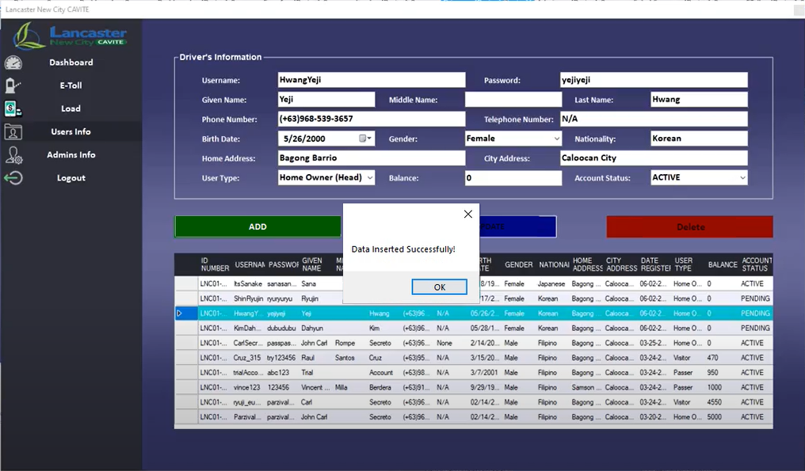

**ALERT MESSAGE**

Step 16: If the new user is inserted successful, it will pop up a message that says “Data Inserted Successfully!” and just click OK to close it and clear all the info so you can do the next process.

Step 17: Updating the account, usually for new users who registered on the mobile application the user will be marked as user status “PENDING”. Meaning the user can’t use the account on the mobile application yet. If the user, asks the admin to activate his account and the admin confirmed that all the details on the account are true, you can go ahead and update the user’s account to ACTIVE. You can also update any info of the user if the user requested it. You can do it by clicking the user you want to update on the table below and it will display all the info of the user above then change whatever you want.

Step 18: Once you are done, click the “UPDATE” button and it will update the info on the database.

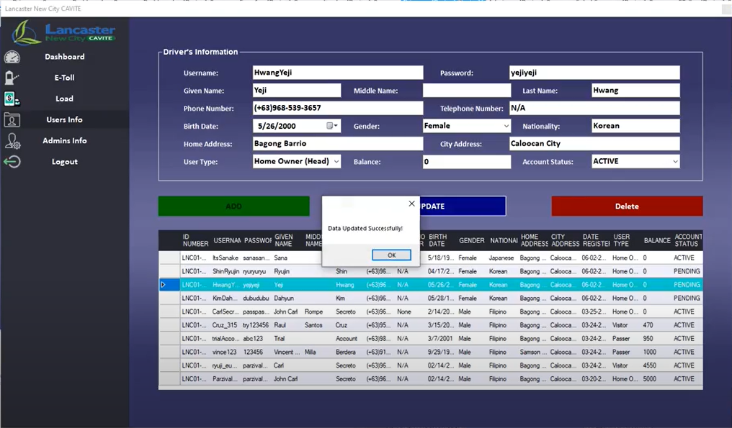

**ALERT MESSAGE**

Step 19: If you updated the user info successfully, it will pop up a message that says “Data Updated Successfully!” and just click OK to close it and clear all the info so you can do the next process.

Step 20: Deleting the account, if the user requested for the account to be deleted you can just click the user you want to delete on the table below.

Step 21: Once you are done, click the “DELETE” button and it will update deletes the info on the database.

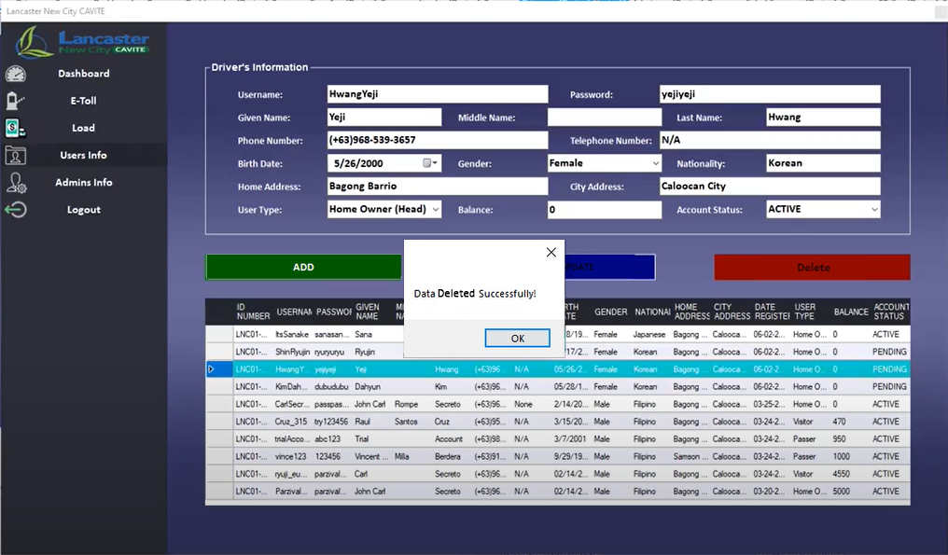

**ALERT MESSAGE**

Step 22: If you deleted the user info successfully, it will pop up a message that says “Data Deleted Successfully!” and just click OK to close it and clear all the info so you can do the next process.

Step 23: Go to the Admin’s Info Menu Page by clicking the “Admin’s Info” button on the sidebar navigation.

**USER’S INFO**

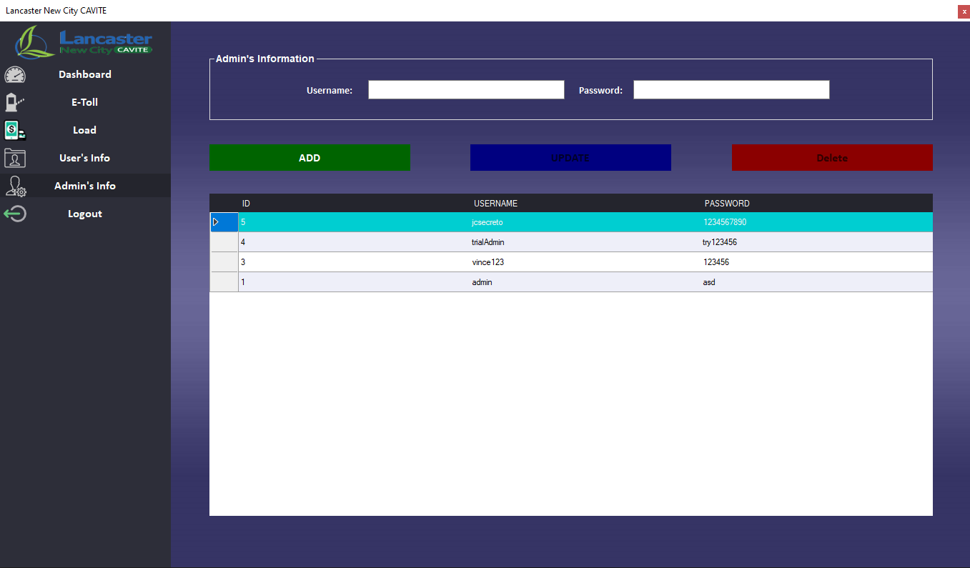

**USER’S INFO TABLE**

**PROCESS BUTTON**

Step 24: Once you are on the Admin’s Info Form the form will display all the Admin’s info below similar to the User’s Info Form.

Step 25: To add a new admin please fill up all the necessary details.

Step 26: Once you are done, click the “ADD” button and if the new admin doesn’t have a similar username on the previews users it will give the account a new ID and the new user will be inserted into the database.

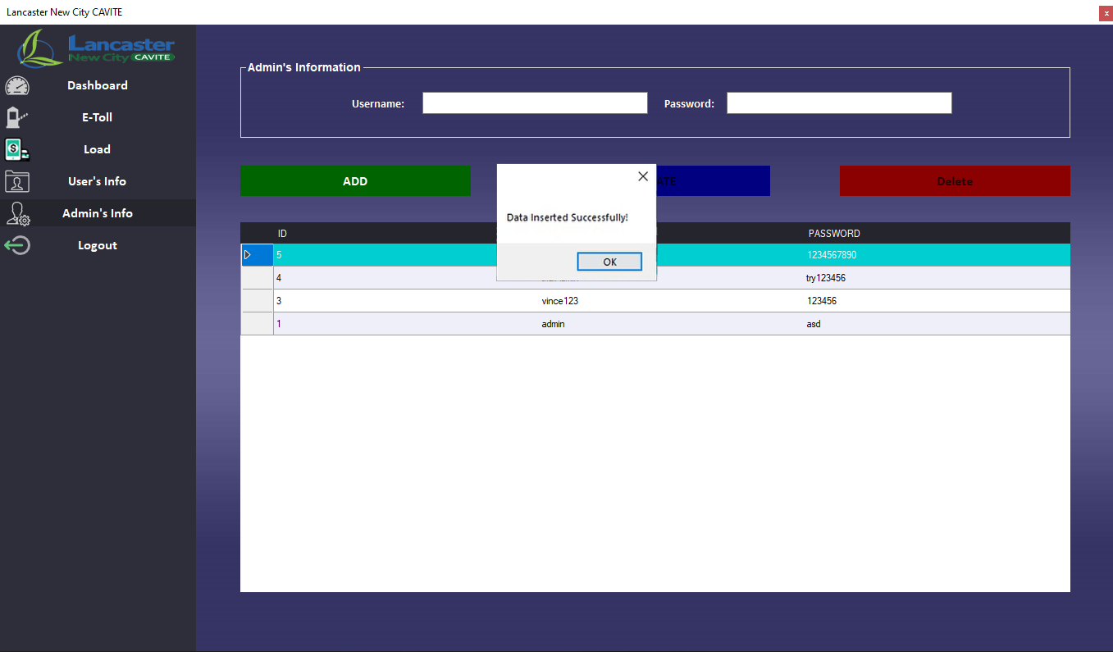

**ALERT MESSAGE**

Step 27: If the new user is inserted successfully, it will pop up a message that says “Data Inserted Successfully!” and just click OK to close it and clear all the info so you can do the next process.

Step 28: For updating the account you can update the username or password of the account if the user requested it or if the user forgets it. You can do it by clicking the user you want to update on the table below and it will display all the info of the user above then change whatever you want.

Step 29: Once you are done, click the “UPDATE” button and it will update the info on the database.

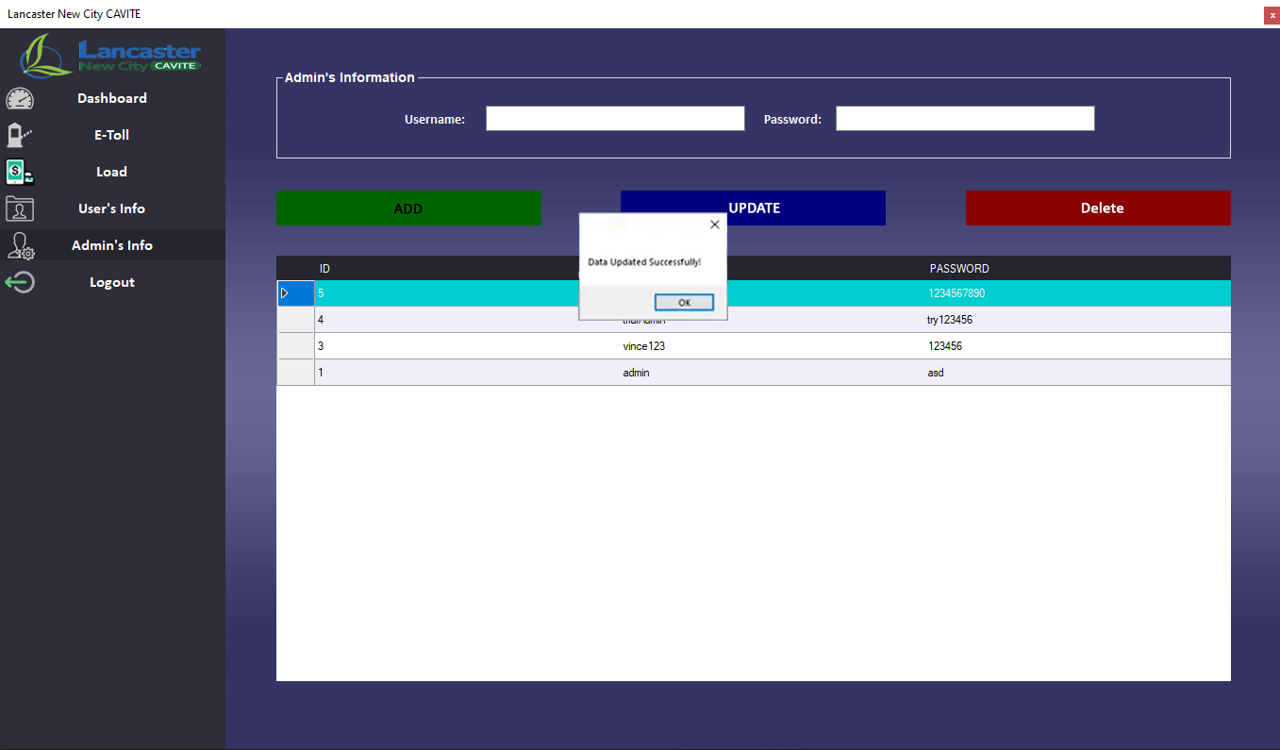

**ALERT MESSAGE**

Step 30: If you updated the admin’s info successfully, it will pop up a message that says “Data Updated Successfully!” and just click OK to close it and clear all the info so you can do the next process.

Step 31: Deleting the account, if the user is not working for the company anymore, you can just click the user you want to delete in the table below.

Step 32: Once you are done, click the “DELETE” button and it will update deletes the info on the database.

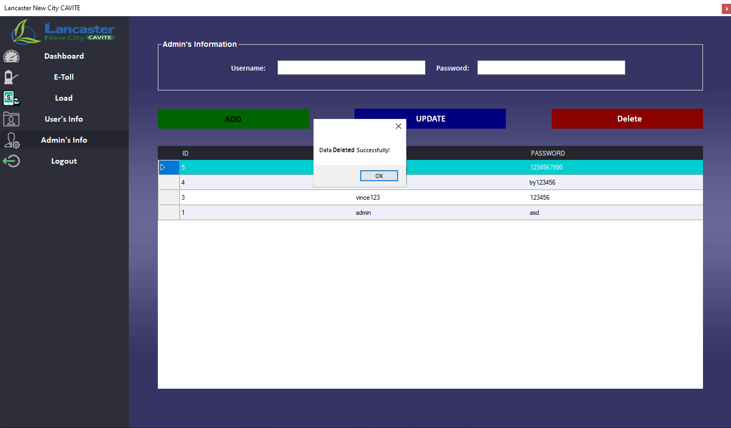

**ALERT MESSAGE**

Step 33: If you deleted the admin’s info successfully, it will pop up a message that says “Data Deleted Successfully!” and just click OK to close it and clear all the info so you can do the next process.